**ASSIGNMENTS ON DIGITAL MARKETING**

**NAME:** DEVA M

**DEPARTMENT:** B.E (ELECTRONICS AND COMMUNICATION ENGINEERING)

**COLLEGE:** 8151 DHANALAKSHMI SRINIVASAN INSTITUTE OF TECHNOLOGY

**NAAN MUDHALVAN COURSE:** DIGITAL MARKETING

**NM ID:** 66117E6F418E60ABC3141479A4A41A37

**ASSIGNMENT 1:**

Create a blog or website using Blogspot and Wordpress. Customize the theme design and post new article with 500 words.

<https://wordpress.com/posts/dchocos.wordpress.com>

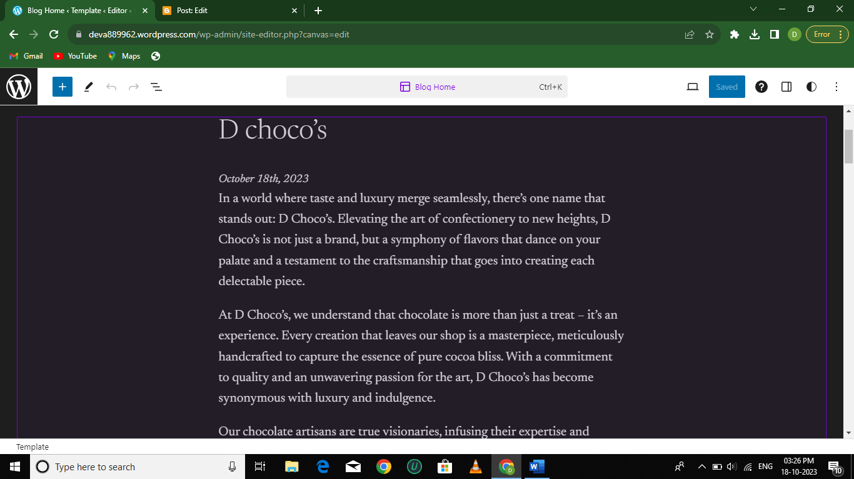

**ASSIGNMENT 2:** Create a new Facebook business page and post one social media poster for your brand.

<https://www.facebook.com/Dchocos>

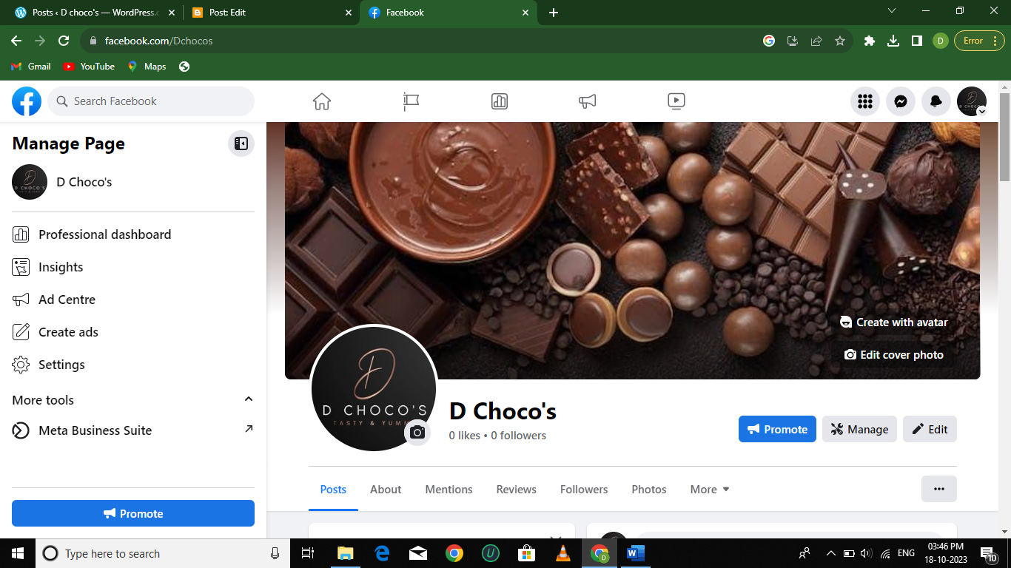

**ASSIGNMENT 3:**

Create and design a social media advertisement poster using canva.

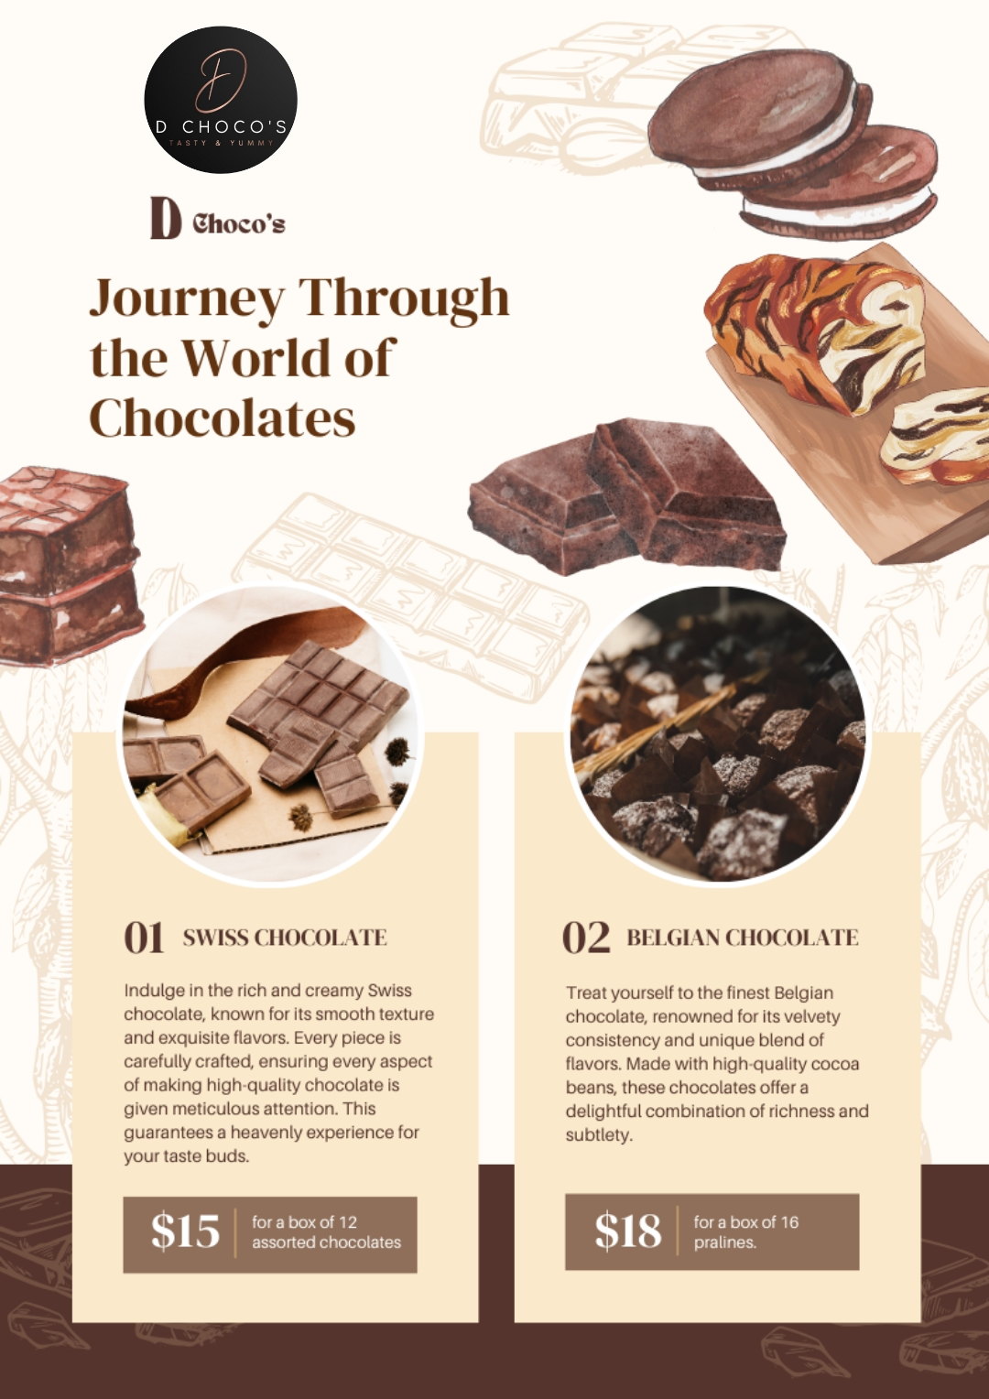

**ASSIGNMENT 4:**

Create email newsletter design using Mailchimp or canva tool.

